**Pom.xml**

<?xml version="1.0" encoding="UTF-8"?>

<project xmlns="http://maven.apache.org/POM/4.0.0" xmlns:xsi="http://www.w3.org/2001/XMLSchema-instance"

xsi:schemaLocation="http://maven.apache.org/POM/4.0.0 https://maven.apache.org/xsd/maven-4.0.0.xsd">

<modelVersion>4.0.0</modelVersion>

<parent>

<groupId>org.springframework.boot</groupId>

<artifactId>spring-boot-starter-parent</artifactId>

<version>2.7.10</version>

<relativePath/> <!-- lookup parent from repository -->

</parent>

<groupId>com.cdac</groupId>

<artifactId>SpringBoot-JDBC-App</artifactId>

<version>0.0.1-SNAPSHOT</version>

<name>SpringBoot-JDBC-App</name>

<description>CURD Operation project for Spring Boot</description>

<properties>

<java.version>11</java.version>

</properties>

<dependencies>

<dependency>

<groupId>org.springframework.boot</groupId>

<artifactId>spring-boot-starter-data-jpa</artifactId>

</dependency>

<dependency>

<groupId>org.springframework.boot</groupId>

<artifactId>spring-boot-starter-jdbc</artifactId>

</dependency>

<dependency>

<groupId>org.springframework.boot</groupId>

<artifactId>spring-boot-starter-web</artifactId>

</dependency>

<dependency>

<groupId>com.mysql</groupId>

<artifactId>mysql-connector-j</artifactId>

<scope>runtime</scope>

</dependency>

<dependency>

<groupId>org.springframework.boot</groupId>

<artifactId>spring-boot-starter-test</artifactId>

<scope>test</scope>

</dependency>

</dependencies>

<build>

<plugins>

<plugin>

<groupId>org.springframework.boot</groupId>

<artifactId>spring-boot-maven-plugin</artifactId>

</plugin>

</plugins>

</build>

</project>

**Application.properties**

# JDBC PROPERTIES

spring.datasource.url=jdbc:mysql://localhost:3306/pune?useSSL=false&allowPublicKeyRetrieval=true

spring.datasource.username=root

spring.datasource.password=cdac

# HIBERNATE PROPERTIES

spring.jpa.properties.hibernate.dialect=org.hibernate.dialect.MySQL5Dialect

spring.jpa.hibernate.ddl-auto=update

## Show sql query.

spring.jpa.show-sql=true

**User.java**

package com.cdac.model;

public class User {

private int id;

private String name;

private String email;

public int getId() {

return id;

}

public void setId(int id) {

this.id = id;

}

public String getName() {

return name;

}

public void setName(String name) {

this.name = name;

}

public String getEmail() {

return email;

}

public void setEmail(String email) {

this.email = email;

}

*@Override*

public String toString() {

return "User [id=" + id + ", name=" + name + ", email=" + email + "]";

}

}

**SpringBootJDBCAppApplication.java**

package com.cdac;

import org.springframework.boot.SpringApplication;

import org.springframework.boot.autoconfigure.SpringBootApplication;

*@SpringBootApplication*

public class SpringBootJdbcAppApplication {

public static void main(String[] args) {

SpringApplication.*run*(SpringBootJdbcAppApplication.class, args);

}

}

**Add_User_Controller.java**

package com.cdac.controller;

import org.springframework.beans.factory.annotation.Autowired;

import org.springframework.jdbc.core.JdbcTemplate;

import org.springframework.web.bind.annotation.RequestMapping;

import org.springframework.web.bind.annotation.RestController;

*@RestController*

public class Add_User_Controller {

*@Autowired*

private JdbcTemplate jdbcTemplate;

*@RequestMapping*("/insert")

public String addUser() {

jdbcTemplate.execute("insert into Table_user(id, name, email) values(155, 'Rajiv', 'rajiv@gmail.com')");

return "data inserted Successfully";

}

}

**update_User_Controller.java**

package com.cdac.controller;

import org.springframework.beans.factory.annotation.Autowired;

import org.springframework.jdbc.core.JdbcTemplate;

import org.springframework.web.bind.annotation.RequestMapping;

import org.springframework.web.bind.annotation.RestController;

*@RestController*

public class Update_User_Controller {

*@Autowired*

private JdbcTemplate jdbcTemplate;

*@RequestMapping*("/update")

public String updateUser() {

jdbcTemplate.execute("update Table_user set name = 'Suresh', email = 'suresh@gmail.com' where id = 15");

return "data Updated Successfully";

}

}

**delete_User_Controller.java**

package com.cdac.controller;

import org.springframework.beans.factory.annotation.Autowired;

import org.springframework.jdbc.core.JdbcTemplate;

import org.springframework.web.bind.annotation.RequestMapping;

import org.springframework.web.bind.annotation.RestController;

*@RestController*

public class Delete_User_Controller {

*@Autowired*

private JdbcTemplate jdbcTemplate;

*@RequestMapping*("/delete")

public String deleteUser() {

jdbcTemplate.execute("delete from Table_user where id = 155");

return "data deleted Successfully";

}

}

**select_User_Controller.java**

package com.cdac.controller;

import org.springframework.beans.factory.annotation.Autowired;

import org.springframework.jdbc.core.JdbcTemplate;

import org.springframework.web.bind.annotation.RequestMapping;

import org.springframework.web.bind.annotation.RestController;

*@RestController*

public class Select_User_Controller {

*@Autowired*

private JdbcTemplate jdbcTemplate;

*@RequestMapping*("/select")

public String selectUserer() {

jdbcTemplate.execute("select * from Table_user where id = 155");

return "data recived Successfully";

}

}

**select_All_User_Controller.java**

package com.cdac.controller;

import org.springframework.beans.factory.annotation.Autowired;

import org.springframework.jdbc.core.JdbcTemplate;

import org.springframework.web.bind.annotation.RequestMapping;

import org.springframework.web.bind.annotation.RestController;

@RestController

public class Select_All_User_Controller {

@Autowired

private JdbcTemplate jdbcTemplate;

@RequestMapping("/select_all")

public String select_All_Users() {

jdbcTemplate.execute("select * from Table_user");

return "data recived Successfully";

}

}

**Project Structure**

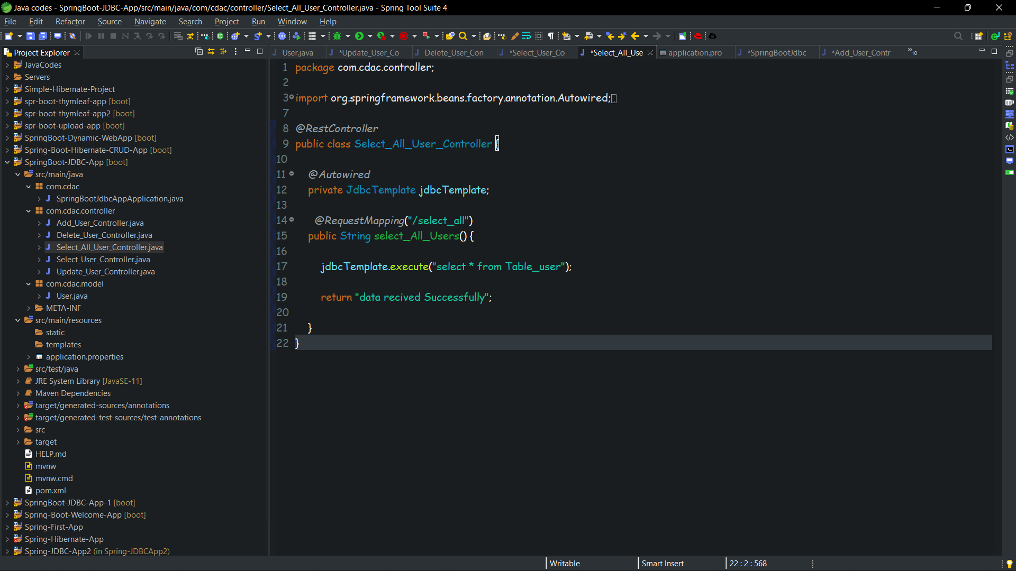

**Database screebShots**

**Insert**

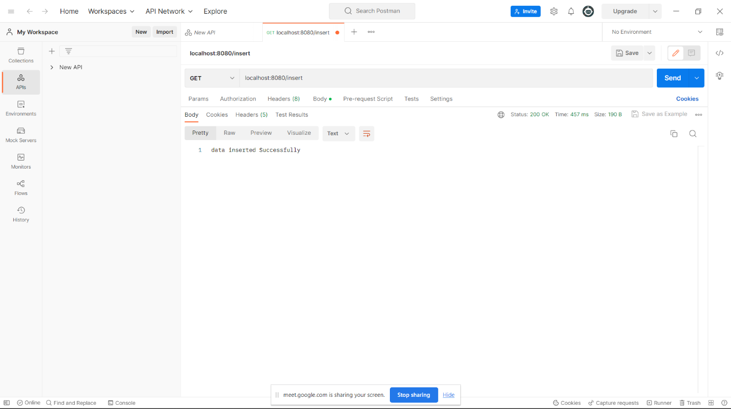

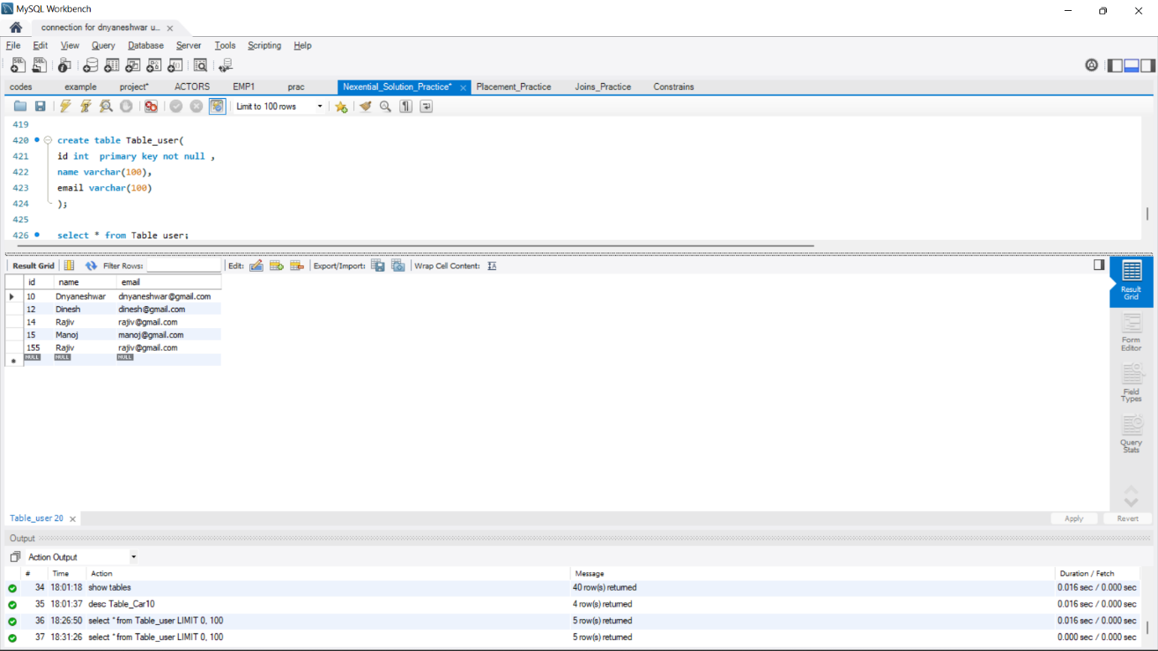

**Update**

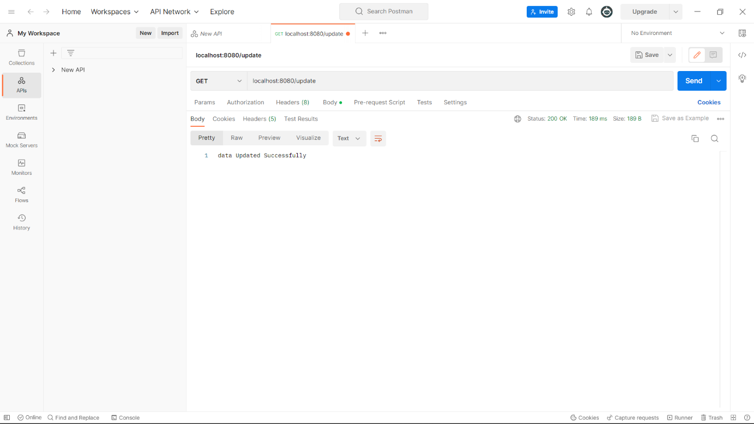

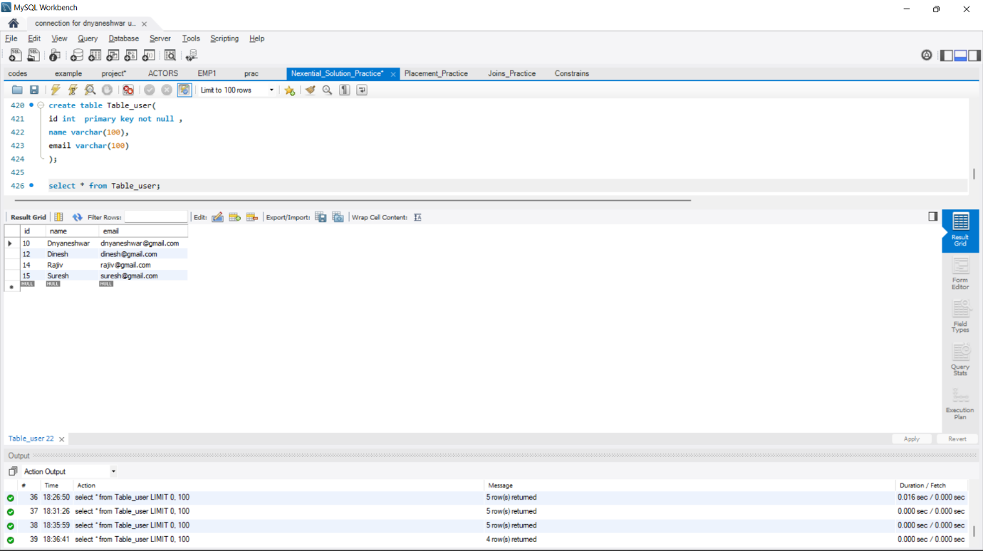

**Delete**

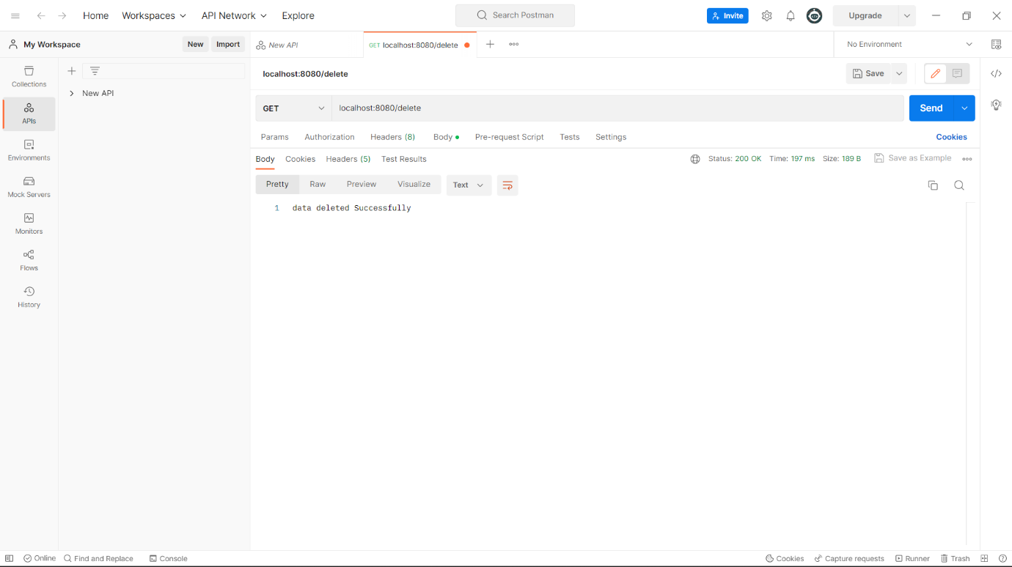

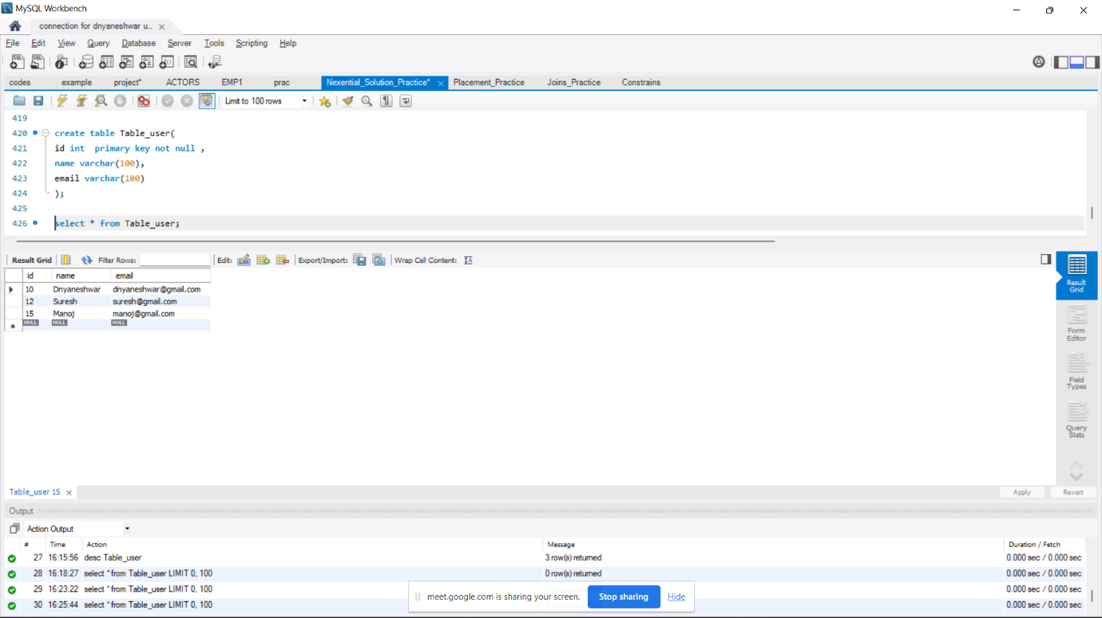

**Select**

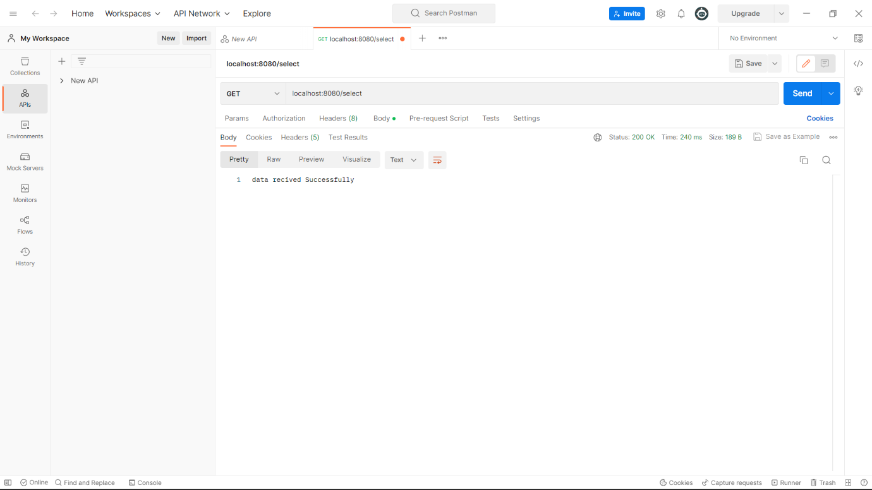

**Select_all**

